Week 3 Lab: Database Authorization
A SQL Server login and a SQL Server database user are two different objects that operate at different layers. A login exists at the SQL Server instance level and controls who can connect to the server. A database user exists inside a specific database and controls what that person can do once they are inside that database. The two are linked by mapping a login to a user, which is what this lab demonstrates. Without that mapping, a login can authenticate to the server but cannot access any database objects.
The three database role privileges used in this lab each authorize a different category of action. The db_datareader role allows the user to run SELECT statements against any table or view in the database, meaning they can read data but not change it. The db_datawriter role allows INSERT, UPDATE, and DELETE operations, so the user can add or modify records. The db_ddladmin role allows the user to create, alter, and drop database objects such as tables and indexes, which is why mynewlogin was able to successfully execute the CREATE TABLE statement while mynewlogin2 (figure 6), assigned only db_datareader, received a permission denied error for the same command.
The most important thing I wish I had known before starting this lab is that SQL Server enforces a strict two-layer access model. It is not enough to create a login; the login must also be explicitly mapped to a database user before any database-level access is possible. I also wish I had known upfront that the database role assignments made during User Mapping directly determine authorization outcomes in ways that are immediately testable, as the contrast between the successful CREATE TABLE under mynewlogin and the denied attempt under figure 6 (mynewlogin2) illustrated clearly. Understanding this separation between authentication (login) and authorization (database user with assigned roles) before starting would have made the purpose of each step easier to follow in real time.

Figure 1: New Login dialog – mynewlogin created with SQL Server authentication, password policy disabled
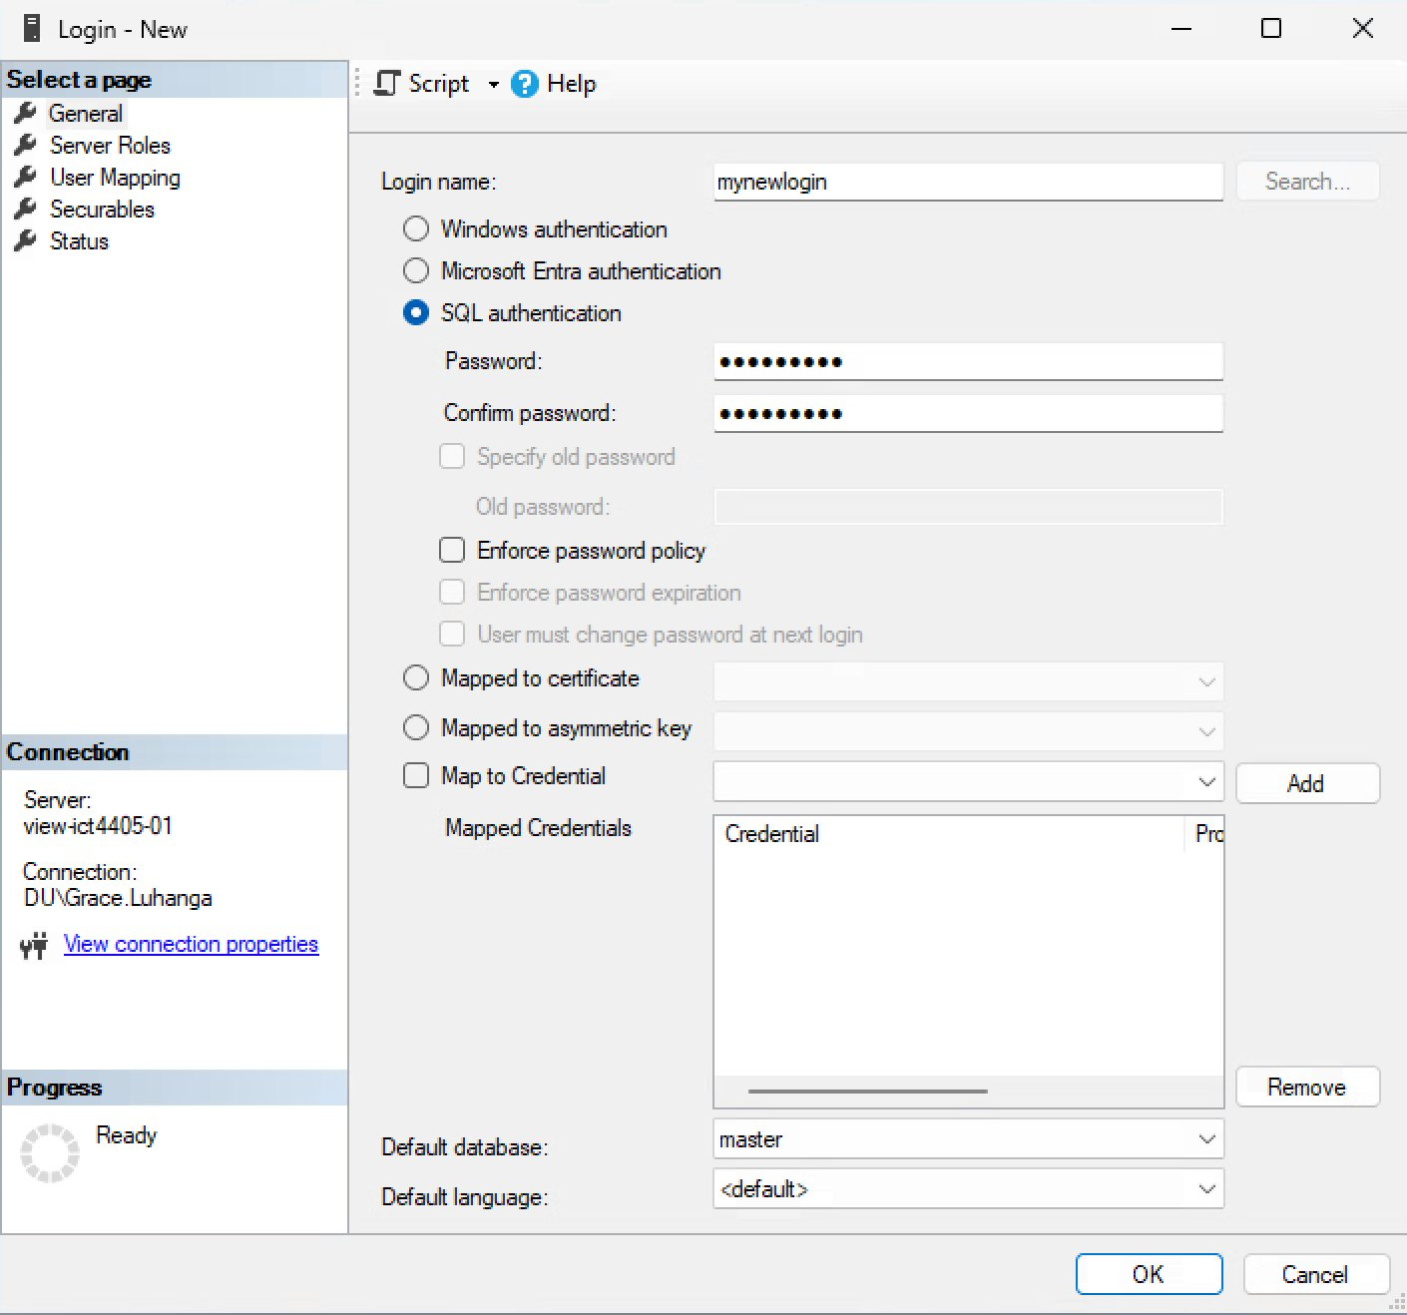
Figure 2: AdventureWorks2025 Users before mapping – only system accounts present, no manually created users
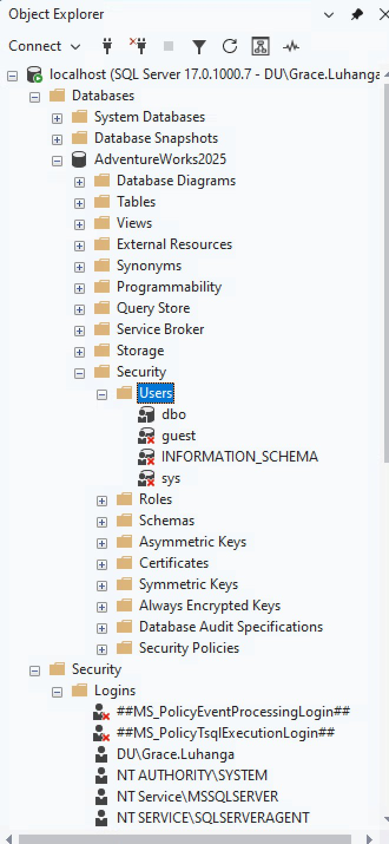

Figure 3: User Mapping for mynewlogin – mapped to AdventureWorks2025 with db_datareader, db_datawriter, and db_ddladmin
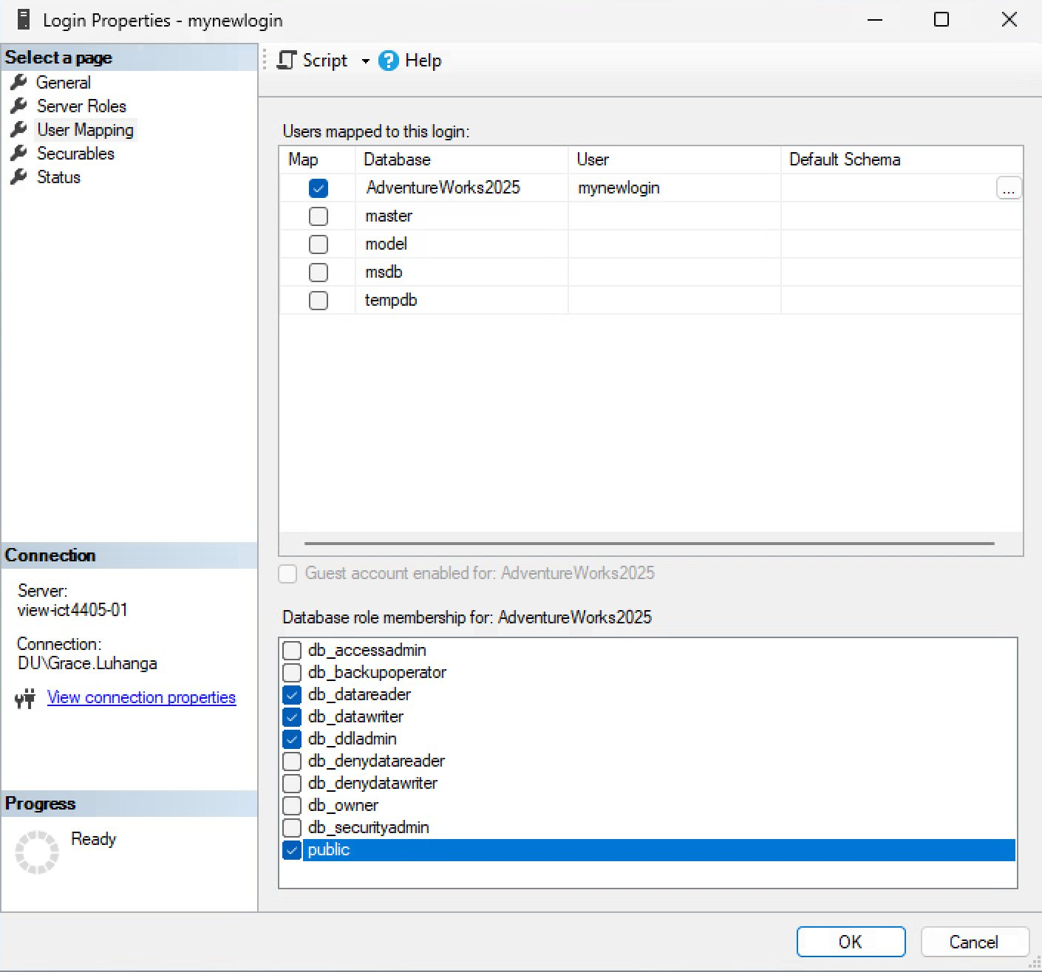

Figure 4: Database User mynewlogin – Membership tab confirming db_datareader, db_datawriter, and db_ddladmin roles
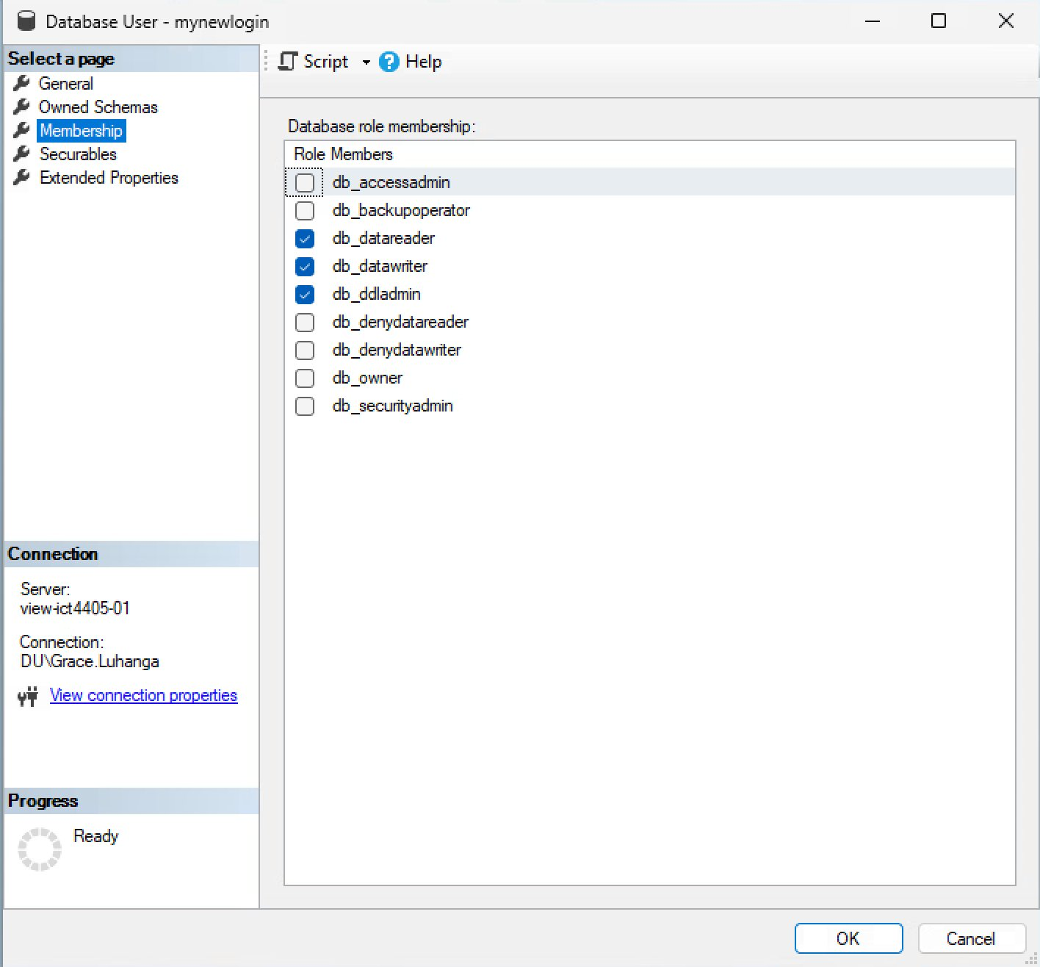

Figure 5: CREATE TABLE executed successfully under mynewlogin – db_ddladmin privilege confirmed
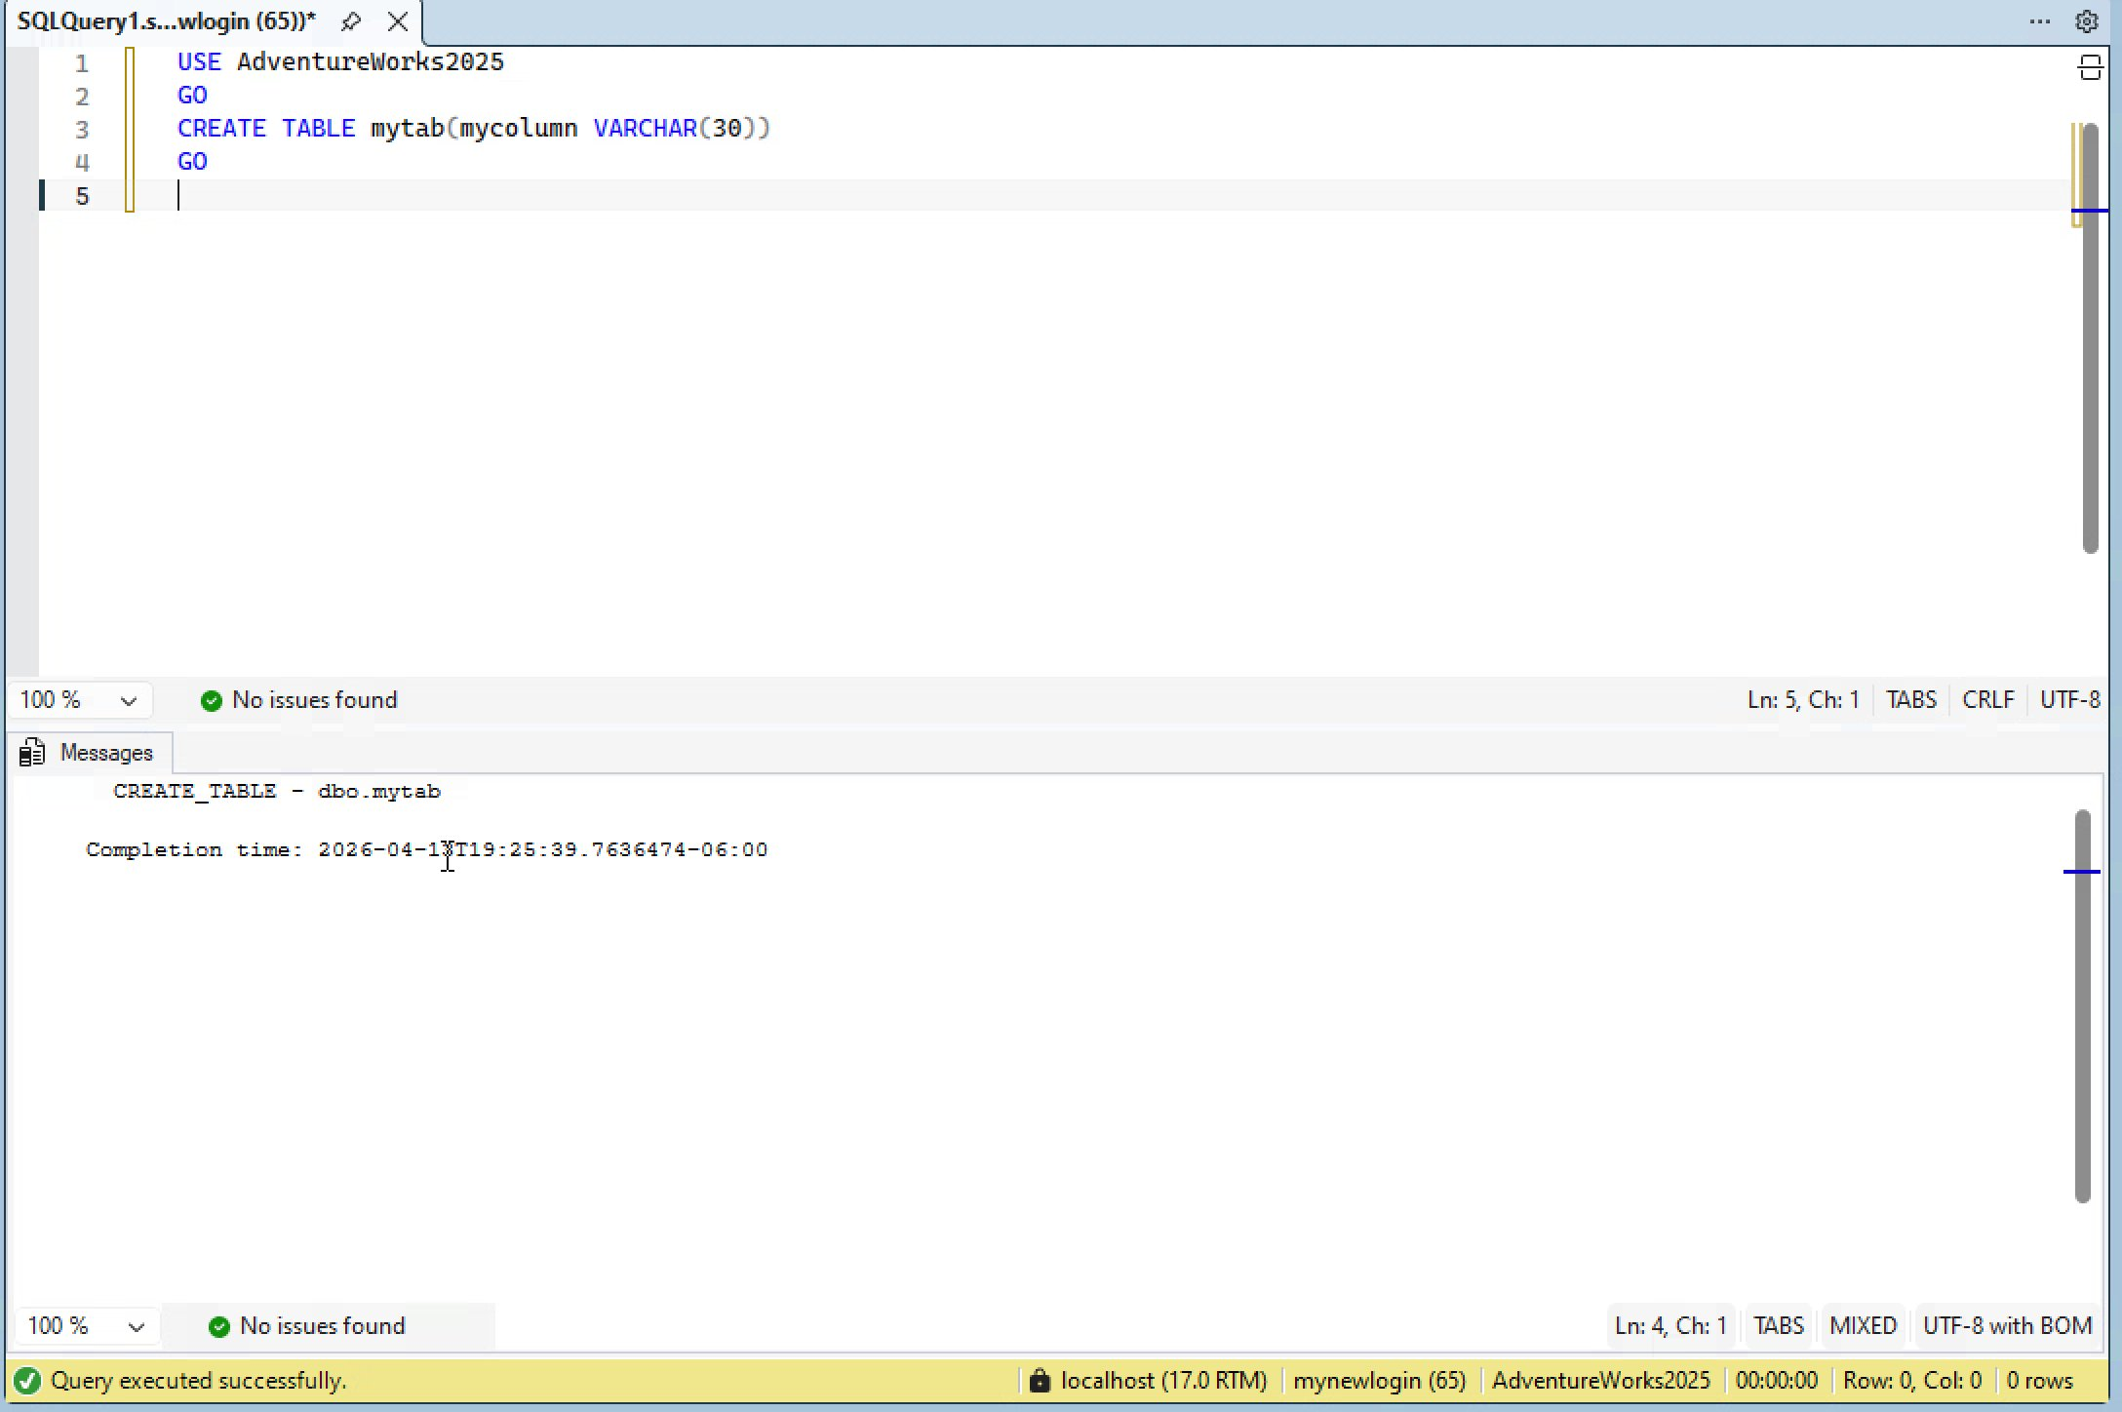

Figure 6: User Mapping for mynewlogin2 – mapped to AdventureWorks2025 with db_datareader only
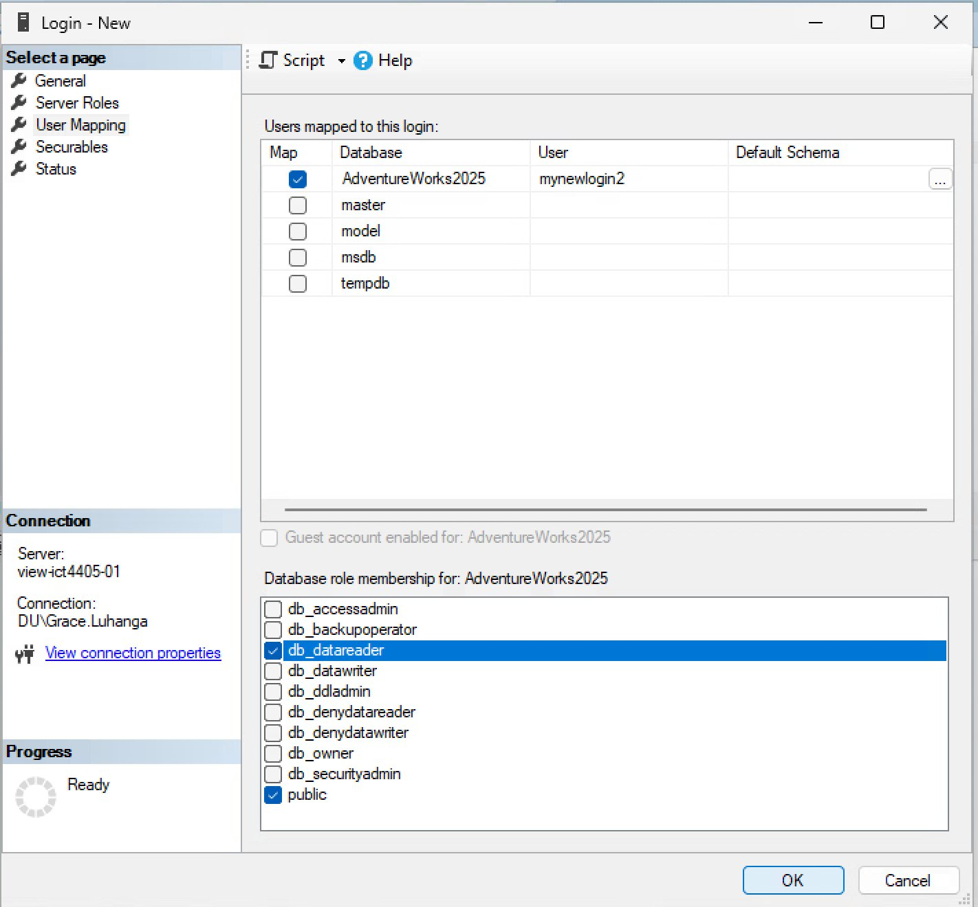

Figure 7: CREATE TABLE denied under mynewlogin2 – db_datareader only, least-privilege principle demonstrated
